**CAFT Functional Guide**

Ver. 1.0

Table of Contents

1. CAFT Folder Structure Setup 3

2. Configuring Common Test Data Sheet 8

3. Configuring Business Component Test Data Sheet 8

4.1 Configuring Single Set TestData Iteration for Execution 8

4.2 Configuring Multiple Set TestData Iteration for Execution 9

4. CAFT Reusable Business Component Model 10

5. CAFT Reusable Function/Support Library Model 11

6. Appendix – A – Business & Support Components Functional Details 12

7.1 Table – 1 – CAFT Support Library Functions Details 12

7.2 Table – 2 – CAFT Reusable Business Components Functional Details 13

7. Appendix – B – CAFT Configuration Settings Details 14

8.1 Table – 1 – Automation HTML Report Design Theme Values 14

8.2 Table – 2 – Uploading Passed Test Cases to Shared Drive Server Values 14

# CAFT Folder Structure Setup

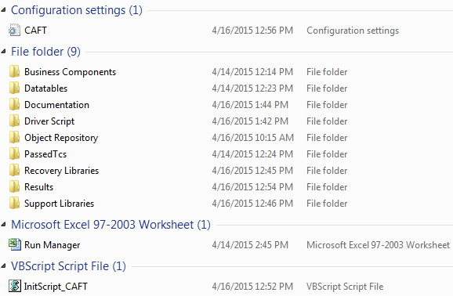

Fig – 1: CRAFT Folder Structure

1. **CAFT.ini** –
   * This is the CAFT configuration settings file contains all the configuration parameters.
   * User can update the parameters settings in the file as per the requirement. Below is the screenshot of the update config file:

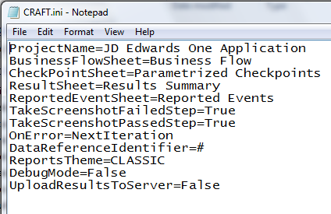

Fig – 2: CRAFT.ini File

* + For e.g. to enable/disable the feature of copying the Passed TC’s to the shared drive, we just need to set the Parameter **“UploadResultsToServer”** value to True/False respectively. Refer Table-1 of Appendix – B for details.
  + Similarly if we want to change the automation report theme we just need to set the Parameter **“ReportsTheme”** value to any of the values given in the Table-2 of Appendix – B:

**NOTE: - For more details regarding reports styles, Refer “Documentation\ReportThemes_Samples” path inside CRAFT framework root folder**

1. **Business Components** –
   * This folder contains all the reusable components of various modules of the application.
   * Only keep those modules in the **“Business Components”** folder which needs to be executed and copy rest of the modules in the **“Backup”** folder
   * **“General.vbs”** component contains generic reusable functions and should be available in **“Business Components”** folder irrespective of the application module being executed

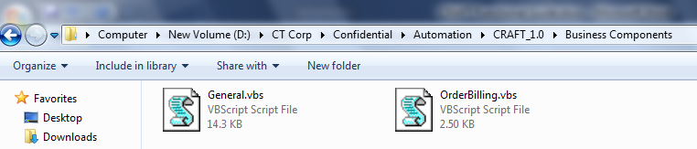

1. **Datatables –** 
   * This folder contains all the Datatables of various modules of the application along with one “Common TestData” Datatable.
   * Only keep those Datatables workbooks in the **“Datatables”** folder which needs to be executed and copy rest of the Datatable files in the **Backup** folder
   * **“Common TestData.xls”** workbook contains general parameters for test execution and should be available in **“Datatables”** folder irrespective of the application module being executed

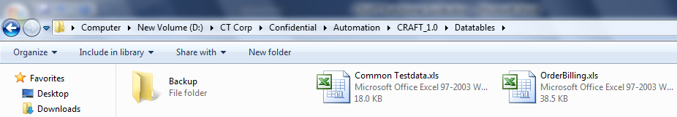

1. **Driver Script** –
   * This folder contains Driver Script for CRAFT Framework which controls and drives the entire framework execution.
2. **Object Repository –** 
   * This folder contains all the Object Repository files (.tsr) of various modules of the application along with one Common Repository file
   * Only keep those Object Repository files in the **“Object Repository”** folder which needs to be executed and copy rest of the object repository files in the **Backup** folder
   * **“Common.tsr”** file contains common objects. And should be available in **“Object Repository”** folder irrespective of the application module being executed

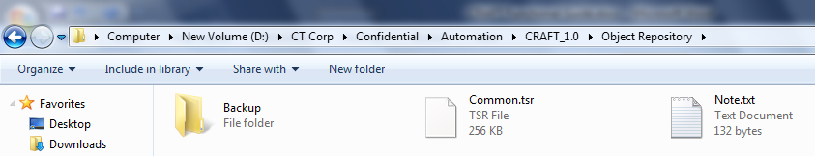

1. **Passed TC’s** –
   * This folder contains all the Passed TC’s after the Test scripts execution
   * CRAFT automatically copies all the Passed TC’s to this folder
2. **Recovery Libraries**
   * This folder contains generic Error Handling & Recovery Scenarios files

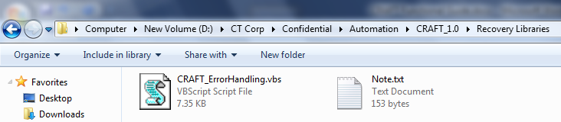

1. **Recovery & Support Libraries**
   * This folder contains generic support function libraries having reusable functions
2. **Results**
   * This folder contains Test Execution Results.
   * The Test Results are stored in 3 formats i.e. **“Excel”**, **“HTML”** & **“QTP”**
   * The screenshots are stored in **“Screenshots”** folder located under **“Results”** folder

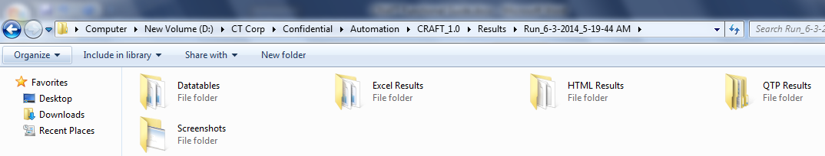

1. **Run Manager.xls** –
   * This workbook contains the set of Test cases & Modules list.
   * For Executing Scripts, select the Scripts with **Execute = “Yes”** in the Run Manager Module level sheet as shown below.
   * Similarly for Executing specific modules, select the modules with Execute **= “Yes”** from Main Sheet

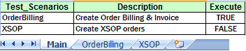

Run-Manager – **Main Sheet**



Run-Manager – **Module Level TC Sheet**

1. **InitScript_CAFT.vbs** –
   * This script is used to start the CRAFT framework

# Configuring Common Test Data Sheet



* As shown in above screenshot user needs to Enter the Application Path in “App_Path” column, “Username”, “Password”, “Environment” details in their respective columns as shown above.
* Also there is one additional column **“ServerPath”** which we need to specify if we have set the Flag value for the Config variable **“UploadResultsToServer”** to True in CRAFT.ini file. This path is where we want our Passed Test Cases should gets copied to the shared drive (\S)

# Configuring Business Component Test Data Sheet

## 4.1 Configuring Single Set TestData Iteration for Execution

* For executing the test scripts on single set of test data, we just have to write the Iteration = 1, SubIteration = 1 and mention the values for Application Path, username, password & Test Environment in **“General_Data”** sheet of Business component workbook as shown in below Fig.
* Values in the App_Path, UserName, Password, Environment Columns are the Test Data ID values (e.g. “CD1”) have been captured from Column (**TD_ID**) of **Common Test Data Sheet**

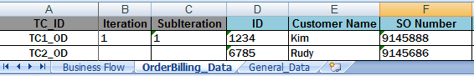

Fig – **“General_Data”** Sheet configuration for Single set Test Data Execution

## 4.2 Configuring Multiple Set TestData Iteration for Execution

* For executing the single test scripts on multiple set of test data, we just have to write the Iteration = 1, SubIteration = 2 and mention the values for Application Path, username, password & Test Environment in **“General_Data”** sheet of Business component workbook as shown in below Fig.
* Values in the App_Path, UserName, Password, Environment Columns are the Test Data ID values (e.g. “CD1”) have been captured from Column (**TD_ID**) of **Common Test Data Sheet**



Fig – **“General_Data”** Sheet configuration for Multiple set Test Data Execution

* Also user needs to update the SubIteration = 2 in Business Component Data Sheet by inserting duplicate rows for same Test Case as shown below

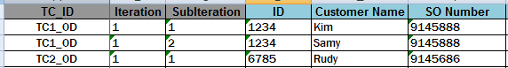

Fig – **“Business Component”** Sheet configuration for Multiple set Test Data Execution

# CAFT Reusable Business Component Model

Module

Business Component

**GENERAL.vbs**

**General_InvokeEWSApp**

**General_Login**

**General_CloseEWSApp**

Fig – CRAFT Reusable Business Component Model

**NOTE: Refer Appendix – A –** **Table-2** **– For Functional Details of Each of the modules**

# CAFT Reusable Function/Support Library Model

Module

Business Component

**CAFT_Support.vbs**

**CRAFT_GetConfig**

**CRAFT_CalculateExecTime**

**CRAFT_GetExpectedResult**

**CRAFT_WrapUp**

**CRAFT_RunIndividualComponent**

**CRAFT_ReportEvent**

**CRAFT_ExportReportedEventsToExcel**

**CRAFT_ExportReportedEventsToHtml**

**CRAFT_SetBusinessFlowRow**

**CRAFT_SetTestDataRow**

**CRAFT_ImportSheet**

**CRAFT_SetCommonData**

**CRAFT_InvokeBusinessComponent**

**CRAFT_GetData**

**CRAFT_PutData**

**CRAFT_SetReportsTheme**

**CRAFT_UpdateResultSummary**

**CRAFT_ExportResultSummaryToExcel**

**CRAFT_ExportResultSummaryToHtml**

**CRAFT_RandomString**

**CRAFT_CopyPassedTCs**

**NOTE: Refer Appendix – A –** **Table-1** **– For Functional Details of Each of the modules**

# Appendix – A – Business & Support Components Functional Details

## 7.1 Table – 1 – CAFT Support Library Functions Details

|  |  |
| --- | --- |
| **Module Name** | **Description / Usage** |
| **CRAFT_ImportSheet** | Imports the Datasheet to the Datatable |
| **CRAFT_SetBusinessFlowRow** | To set the current row in Business Flow Sheet based on the current test case |
| **CRAFT_SetTestDataRow** | To set the current row in Test Data and Checkpoints sheet based on the current test case iteration |
| **CRAFT_SetCommonDataRow** | To set the current row in Common Test Data sheet based on the referenced row |
| **CRAFT_InvokeBusinessComponent** | To invoke the corresponding Business component based on the keyword passed |
| **CRAFT_GetData** | To get the test data value from Business Component sheet corresponding to the Column/Field Name specified |
| **CRAFT_PutData** | To write any value to the test data or any other sheet under the Column/Field Name specified |
| **CRAFT_GetExpectedResult** | To return the expected result data (from the Parameterized Checkpoints sheet) corresponding to the field name passed |
| **CRAFT_GetConfig** | To get the configuration data from the CRAFT.ini configuration file |
| **CRAFT_CalculateExecTime** | To do calculate the execution time for the current iteration |
| **CRAFT_WrapUp** | Invoked at the end of the Test Script execution. This is mainly used to do required wrap-up work after running a Test case. For e.g. Test Execution Time Calculation, Reports Exporting to different format, Copying Passed Test Cases to the specified location if configured |
| **CRAFT_RunIndividualComponent** | To enable running of an individual business component independent of the Driver script |
| **CRAFT_ReportEvent** | To report any event related to the current Test Script |
| **CRAFT_ExportReportedEventsToExcel** | To export the reported events in the Test Script being executed to Excel |
| **CRAFT_SetReportsTheme** | To Set the Automation HTML Report design theme value based on the value defined by user in CRAFT.ini configuration file. For more details about the values of Report themes, Refer Appendix – B – Table-1 |
| **CRAFT_ExportReportedEventsToHtml** | To Export the Test Script events into HTML report format |
| **CRAFT_UpdateResultSummary** | To update the Results Summary with the current Test Case Iteration status |
| **CRAFT_ExportResultSummaryToExcel** | To exported the Results Summary sheet to Excel |
| **CRAFT_ExportResultSummaryToHtml** | To exported the Results Summary sheet to HTML |
| **CRAFT_RandomString** | To generate a alphanumeric random string of the length being passed by the user |
| **CRAFT_CopyPassedTCs** | To copy the Passed Test Scripts to the location specified by the user |

## 7.2 Table – 2 – CAFT Reusable Business Components Functional Details

|  |  |
| --- | --- |
| **Module Name** | **Description / Usage** |
| **General_InvokeEWSApp** | This component is used to Invoke the Rufus Application |
| **General_Login** | This component contains the business logic to login to the Rufus application using UserId & Password read from “Common TestData.xls” workbook |
| **General_CloseEWSApp** | This component is used to close the Rufus Application |

# Appendix – B – CAFT Configuration Settings Details

## 8.1 Table – 1 – Automation HTML Report Design Theme Values

|  |  |
| --- | --- |
| **Report Theme Name** | **Report Theme Value** |
| **Autumn** | AUTUMN |
| **Classic** | CLASSIC |
| **Default** | DEFAULT |
| **Mystic** | MYSTIC |
| **Olive** | OLIVE |
| **Rebel** | REBEL |
| **Retro** | RETRO |
| **Serene** | SERENE |

## 8.2 Table – 2 – Uploading Passed Test Cases to Shared Drive Server Values

|  |  |
| --- | --- |
| **Variable Name** | **Variable Value** |
| **UploadResultsToServer** | True |
| False |